**Introduction to Artificial Intelligence — C951 Task 2**

**Name**: Rafael Pimentel

**ID**: 001454692

**A: Disaster Recovery Environment Description**

The simulated disaster recovery environment represents a building blackout caused by a power failure, where visibility is minimal. To enhance realism, **three structural pillars** are placed within the environment, serving as physical obstacles the robot must navigate around. Additionally, **two red-colored pillars symbolize people trapped in the building**, who the robot will locate and assist.

This scenario simulates the conditions of an emergency response where visibility is critical, especially for detecting individuals. The robot is equipped with night vision capabilities (NVG), allowing it to function effectively despite the low-light environment.

**B: Disaster Recovery Enhancement by the Robot**

The robot aids in locating individuals trapped in the blackout-affected building by leveraging a night vision (NV) sensor, which detects obstacles in its path. When the NV sensor detects an obstruction, the robot automatically rotates a few degrees to navigate around it, allowing for continuous, systematic searching within the environment. This ensures the robot can move through the affected area without unnecessary stops or delays, optimizing its coverage.

Additionally, the robot is equipped with a secondary heat sensor capable of detecting heat signatures, which helps identify the presence of people in distress. This feature allows the robot to pinpoint locations of potential victims even if they are not immediately visible, providing crucial information on their whereabouts.

The robot transmits real-time footage to the search and rescue team through a broadcasted video feed, enabling them to view the layout and status of the environment remotely. This information helps responders assess environmental hazards and prioritize rescue efforts, making the operation more efficient and reducing risks to personnel.

**C: Justification of Robot Modifications and Sensor Selection**

To optimize the robot for search and rescue operations in low-visibility disaster scenarios, I added two key sensors: a **primary navigational sensor** and a **secondary “heat sensor”**, each configured to enhance the robot’s efficiency in locating victims and broadcasting environmental data to responders.

1. **Navigational Sensor**: The primary sensor is a 45-degree, front-facing cone responsible for detecting obstacles. Its footage is streamed to incident responders, enabling them to monitor the robot’s surroundings in real-time. Upon detecting an obstacle, the sensor prompts the robot to adjust its direction, maintaining a continuous search without unnecessary stops. This sensor is essential for autonomous navigation in low-visibility, obstructed environments typical of disaster sites.
2. **Heat Sensor**: Positioned with a slight forward offset relative to the navigational sensor, this secondary heat sensor also covers a 45-degree cone. Its purpose is to detect the presence of trapped individuals through heat signatures before they are within the navigational sensor’s range. The heat sensor’s offset configuration prevents interference with the navigational sensor, and changes colors when finding a person.

Additionally, I introduced code in the robot’s logic to handle victim detection and initiate color-coded responses:

* **Counter Initialization**: An empty counter (num_To_Detect) is initialized within the main function to record each detection event.
* **Object Detection Logic**: The **syscall_actuation()** function includes code to identify objects with the alias "**Person_To_Detect**," updating the counter and changing the sensor’s color indicator to green upon detection. If no object is detected, the sensor color remains blue, providing visual feedback on the robot’s search status.

**D: Internal Representation of the Environment**

The robot creates an internal representation of its surroundings through data captured by its sensors. This representation allows it to navigate autonomously and locate victims within the blackout-affected environment. The robot’s actuation function contains logic to print the name of found victims for logging purposes.

1. **Obstacle Mapping**: The primary navigational sensor continuously detects obstacles within its 45-degree range, helping the robot build an internal obstacle map as it traverses the area. Each detected object is marked, and the robot adjusts its path accordingly to avoid collisions. This sensor-driven mapping allows the robot to identify passable routes within the environment.
2. **Heat Signature Identification**: The secondary heat sensor provides an additional layer of environmental data by identifying heat signatures that indicate the presence of people. When a person is detected, the robot’s logs are updated to record the location, allowing responders to locate victims.
3. **Positional Awareness and Search Coverage**: The robot keeps track of its movement and coverage area through its sensor data and directional adjustments, avoiding revisiting mapped sections unnecessarily. This approach maximizes the robot’s area coverage, allowing it to focus on unsearched zones.

Overall, this internal environment representation equips the robot with situational awareness essential for real-time disaster recovery, allowing it to relay critical location data as well as live footage to incident responders while autonomously navigating through the area.

**E: Implementation of Key Concepts for Goal Achievement**

The robot’s victim-seeking behavior in a disaster recovery scenario relies on four fundamental concepts: reasoning, knowledge representation, uncertainty, and intelligence. Each plays an essential role in ensuring the robot can autonomously navigate, locate victims, and support responders.

1. **Reasoning**: The robot employs reasoning to make decisions about navigation and victim detection. Using data from its sensors, it determines its path and actions based on environmental conditions. For example, when an obstacle is detected, reasoning allows the robot to decide to rotate and continue searching, rather than halting or revisiting previously mapped areas. This reasoning enables the robot to respond dynamically to real-time input.
2. **Knowledge Representation**: The robot maintains an internal model of its environment, effectively representing known obstacles (walls and pillars) and victims’ locations. The robot also broadcasts its findings in real-time to incident responders. The robot’s knowledge is updated continuously based on sensor feedback, allowing him to make informed decisions.
3. **Uncertainty**: Uncertainty is common in disaster environments, where visibility is limited, and obstacles or victim’s locations may be unpredictable. The robot’s design accounts for uncertainty by utilizing redundant sensing methods, like the heat sensor and NV sensor, to verify findings. For example, the heat sensor provides a confirmation mechanism for detecting human presence, which helps manage uncertainty about victim locations and reduces the risk of false positives.
4. **Intelligence**: Intelligence in the robot is exhibited through autonomous navigation and ability to broadcast meaningful information to responders. The robot processes sensor data to adapt its movement patterns and detection methods, demonstrating situational awareness. By combining sensor feedback with pre-programmed goal-seeking behaviors, the robot can independently perform complex tasks, like victim detection and obstacle avoidance, effectively contributing to the disaster recovery effort.

**F: Potential Improvements to the Prototype**

Several advancements could increase the robot’s functionality and adaptability, making it a more useful asset in disaster recovery scenarios:

1. **Dual Operational Modes**: Implementing a remote-control mode alongside its autonomous capabilities would give incident responders the flexibility to control the robot manually in particularly complex or unpredictable situations. While the autonomous mode allows for systematic exploration and victim detection, a remote option would allow responders to direct the robot’s actions as needed, providing greater flexibility in diverse environments.
2. **Enhanced Communication Features**: Adding speakers and microphones would allow the robot to establish two-way communication with victims. This feature would enable responders to reassure trapped individuals, provide instructions, and assess their well-being, extending the robot’s role as an intermediary in disaster situations.
3. **Searchlights and Environmental Sensors**: Searchlights could be added to help illuminate dark areas, improving the robot's visual data collection and allowing it to operate in pitch-dark conditions. Furthermore, hazardous smoke sensors and air quality sensors could detect dangerous gases or low oxygen levels, helping responders assess the environment's safety before entering.
4. **Fire Extinguishing and Waterproofing Capabilities**: Equipping the robot with fire extinguishers would enable it to mitigate fire hazards encountered in disaster zones, reducing the risk to both victims and responders. Waterproofing would make the robot suitable for flooded areas, expanding its applicability in different disaster scenarios.
5. **Advanced Reinforced Learning and Search Algorithms**: Reinforced learning could enable the robot to learn from its interactions within the environment, adapting its behavior over time based on feedback. For example, by “learning” effective navigation paths and obstacle avoidance tactics in real time, the robot would improve its efficiency in similar future scenarios. Advanced search algorithms like A* or Dijkstra’s algorithm could further optimize pathfinding by finding the shortest, safest paths to victims, reducing search times and conserving the robot’s energy.
6. **Cost-Effective Models for Different Budgets**: Offering a range of models with varying feature sets would make the robot more accessible to different organizations, allowing them to select the model best suited to their operational needs and budget. A basic model could focus on fundamental navigation and victim detection, while more advanced versions could include reinforced learning, searchlights, environmental sensors, and other features for high-stakes operations.

**G: Robot Code**

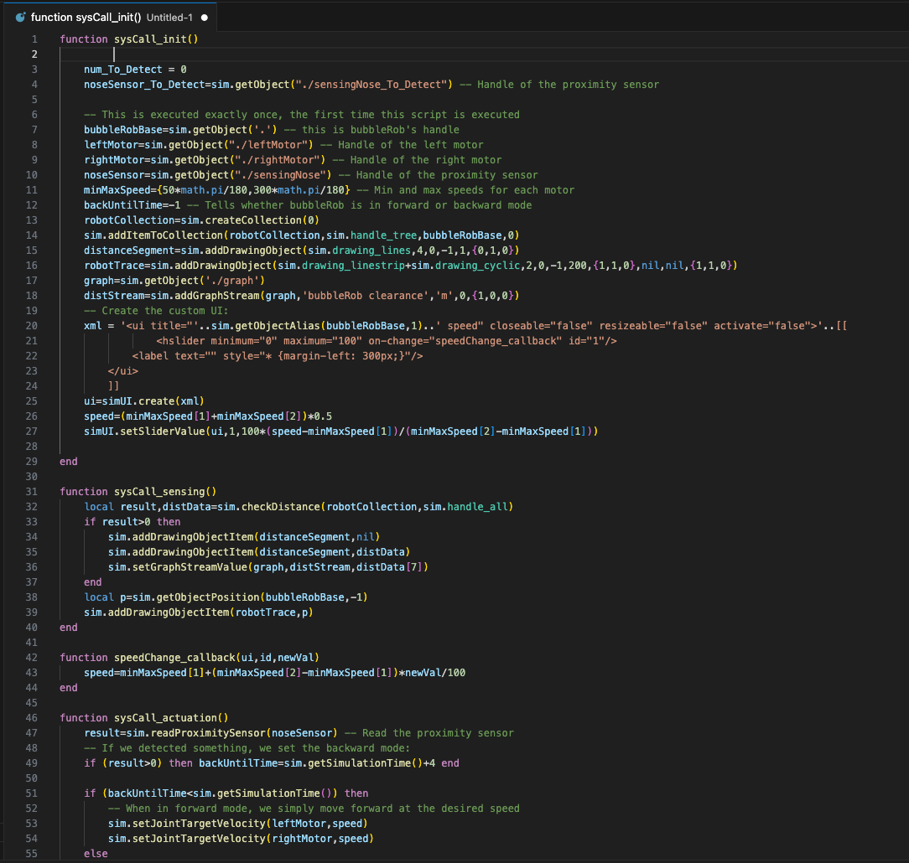

**H. Panopto Video**

[Recording link](https://wgu.hosted.panopto.com/Panopto/Pages/Viewer.aspx?id=ee18c021-7375-40c9-afe2-b21700e65f39).

**I. Sources**

No sources used.